
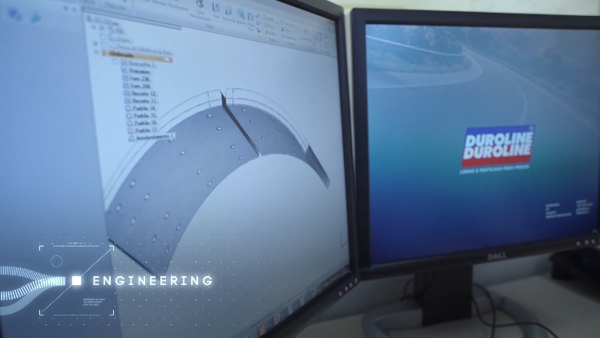
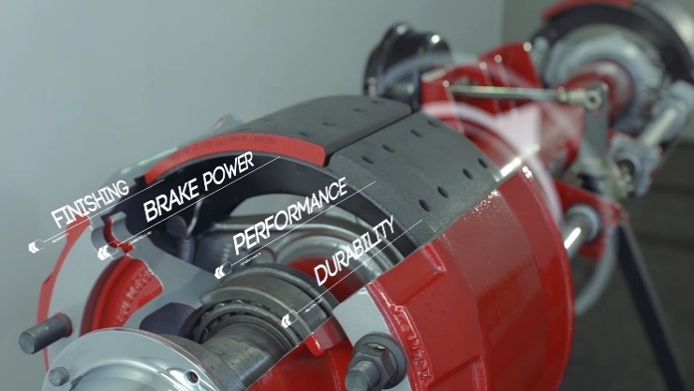
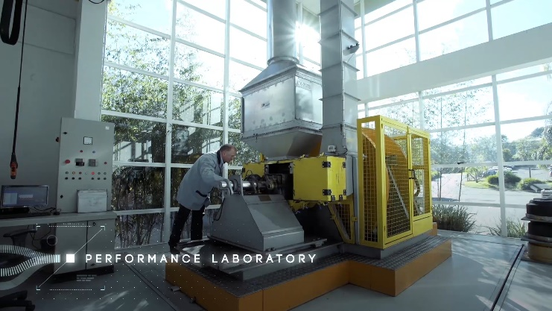
FORMULATION TECHNICAL SHEET
Notes:
______________________________________________________________________________________________________________________________________________________________________________________________________________________________________________________________________________________________________________________________________________________________________________________________________________________________________________________________________________________________________________________________________________________________________________________________________________________________________________________________________________________________________________
Contact Information:

Name: _______________________________
Phone: _______________________________
E-mail: _______________________________
APPLICATION:
DNA-11 is a 23,000 GAWR OEM performance formula with excellent results on vocational trucks and trailers.
It differs from the competition by using fine grit abrasives instead of coarse ones, making it a very drum friendly material while reducing the stopping distance.
The added heat exchanging fillers provide cooler running brakes, meaning that the DNA-11 will serve demanding operations without compromising wear.
DNA-11

SPECIFICATIONS:
- Density: 1.87
- Friction Cold: 0.50
- Friction Hot: 0.44
- Classification: GF
- GAWR: 23,000 lbs.

Improved results over:
Abex 6149, Marathon FLOE, Fras-le 555-1 and Meritor MG2

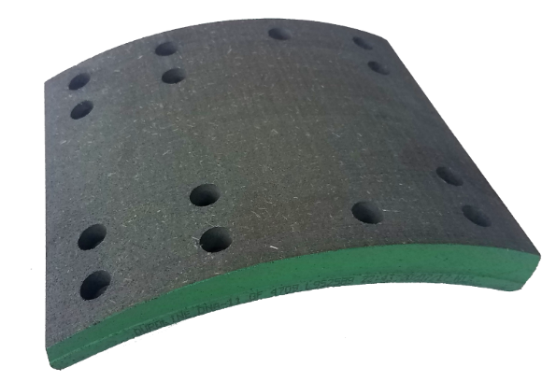
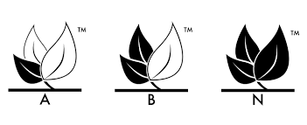
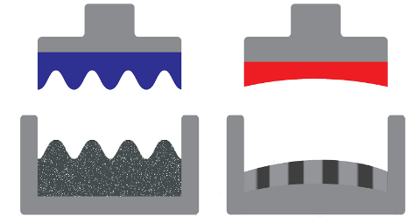

DNA-11 Formula Highlights
Heat Exchanging Fillers
Fiberglass Reinforced
Fine Grit Abrasives
Hot Pressing
Result: Oriented Columns of
Different Densities
Cold Pressing

Higher density columns increase product life
Lower density columns improve stopping performance

